Rubidium clocks

Definition:
# Source: AI Source: Provided by: [Data Path: Persons Table -> ID Column: 1, Name_En Column: Motasem Essam] -> From: [ChatGPT] on [1/26/2026]
Rubidium clocks are a type of atomic clock that use rubidium atoms to keep very precise time. They are smaller, cheaper, and more practical than cesium atomic clocks, but slightly less accurate.

How rubidium clocks work
# Source: AI Source: Provided by: [Data Path: Persons Table -> ID Column: 1, Name_En Column: Motasem Essam] -> From: [ChatGPT] on [1/26/2026]
- Rubidium atoms as the reference:
  - Rubidium atoms have a specific vibration frequency between energy levels.
  - The clock uses this vibration as a “tick” to measure time.
- Microwave excitation:
  - Microwaves stimulate the rubidium atoms, and the clock adjusts its frequency until the atoms respond correctly.
- Counting vibrations:
  - The electronic circuitry counts the atoms’ vibrations to generate a precise time signal.

Accuracy
# Source: AI Source: Provided by: [Data Path: Persons Table -> ID Column: 1, Name_En Column: Motasem Essam] -> From: [ChatGPT] on [1/26/2026]
- Less precise than cesium clocks, but still very good:
  - Typical rubidium clocks drift about 1 second every few years.
- Very stable and suitable for medium-accuracy applications where size, cost, and power consumption matter.

Common uses
# Source: AI Source: Provided by: [Data Path: Persons Table -> ID Column: 1, Name_En Column: Motasem Essam] -> From: [ChatGPT] on [1/26/2026]
- Satellites and spacecraft
- Telecommunications networks
- Backup atomic clocks for NTP servers
- Laboratory and scientific experiments

Quick comparison: Cesium vs Rubidium
# Source: AI Source: Provided by: [Data Path: Persons Table -> ID Column: 1, Name_En Column: Motasem Essam] -> From: [ChatGPT] on [1/26/2026]
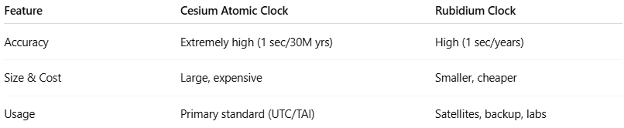
Feature | Cesium Atomic Clock | Rubidium Clock
Accuracy | Extremely high (1 sec/30M yrs) | High (1 sec/years)
Size & Cost | Large, expensive | Smaller, cheaper
Usage | Primary standard (UTC/TAI) | Satellites, backup, labs

✅ Summary:
# Source: AI Source: Provided by: [Data Path: Persons Table -> ID Column: 1, Name_En Column: Motasem Essam] -> From: [ChatGPT] on [1/26/2026]
A rubidium atomic clock is a precise, smaller, and cheaper atomic clock that uses the vibrations of rubidium atoms to measure time. It’s commonly used in satellites, telecom networks, and as backup for high-accuracy time systems.

